CS 504 Software Engineering - HOS08A - CI/CD - Manas Teja Katakam
A. Creation of a Static Website
- Created the HOS08 repository on GitHub.
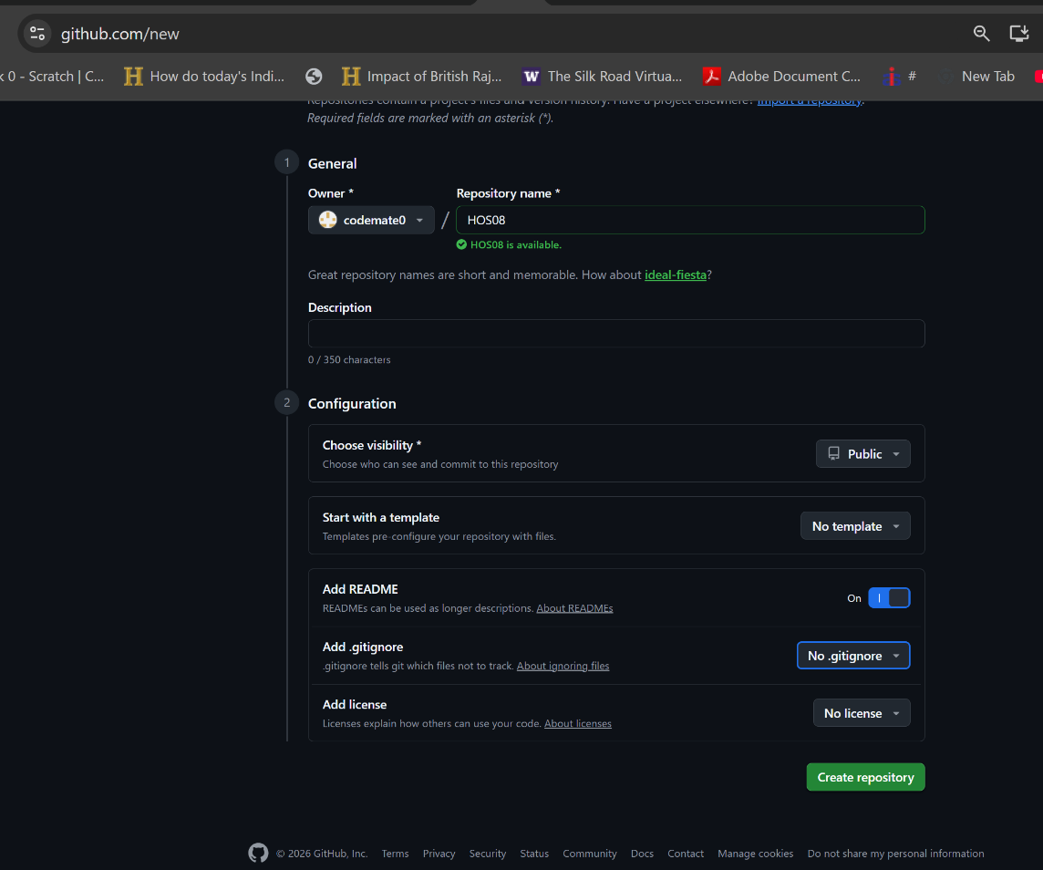
- Repository created as public with a README.
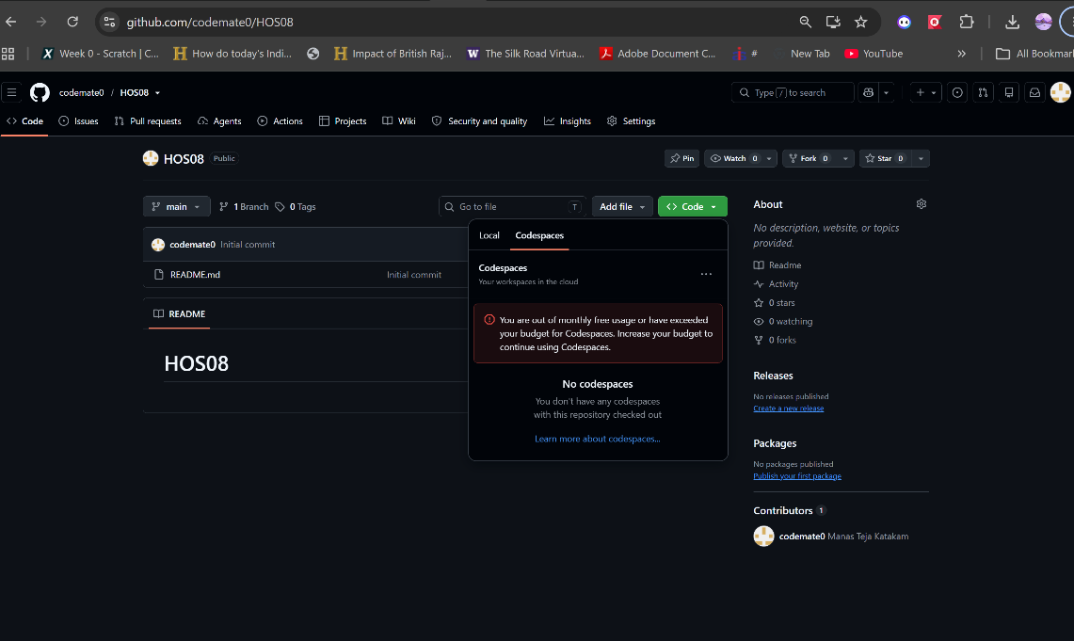

- Added index.html with the Hello heading and pushed it to main.
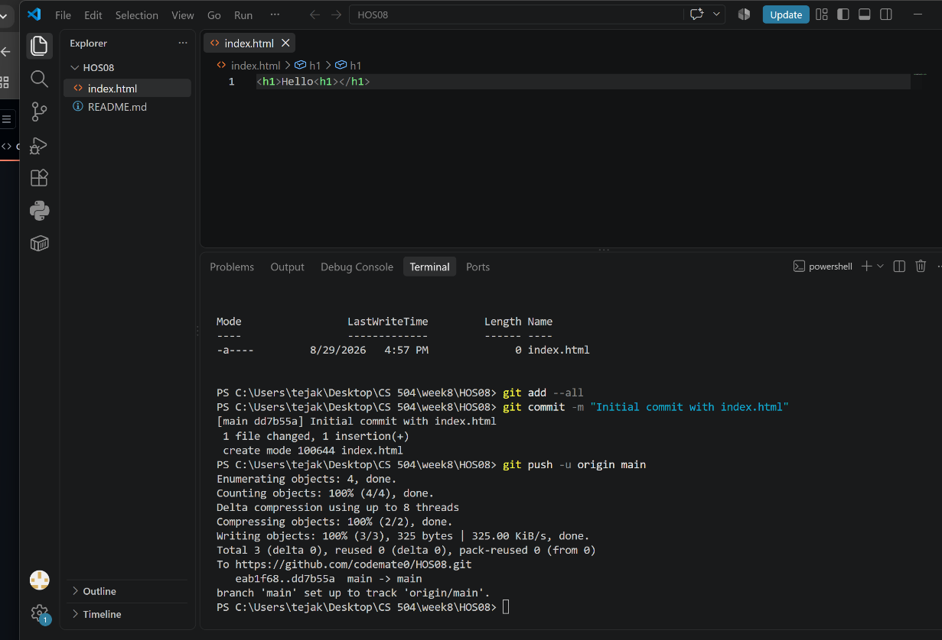

B. Azure Sign-In and the Static Web Apps Block
- Signed in to the Azure portal with the Azure for Students subscription.
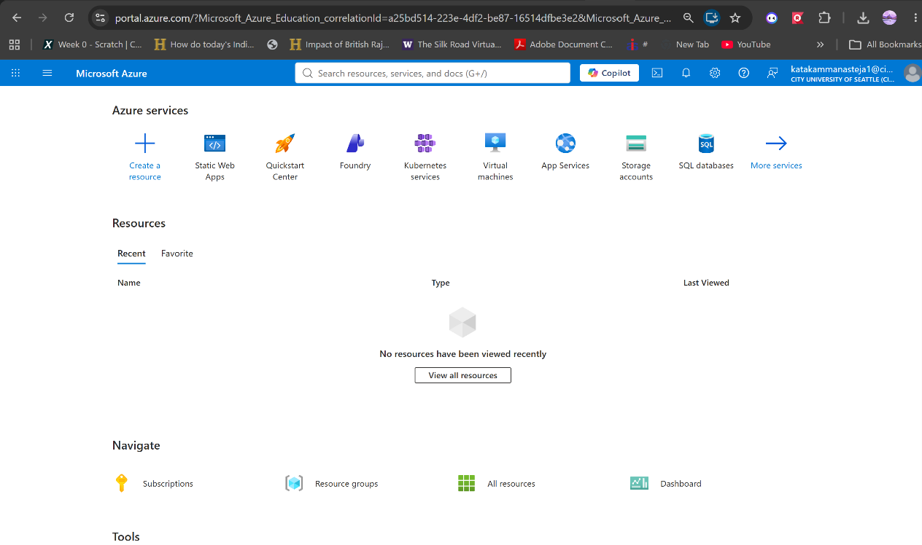

- Entered the Static Web App details the HOS specifies - name HOS08, Free plan, GitHub source, repository codemate0/HOS08, branch main.
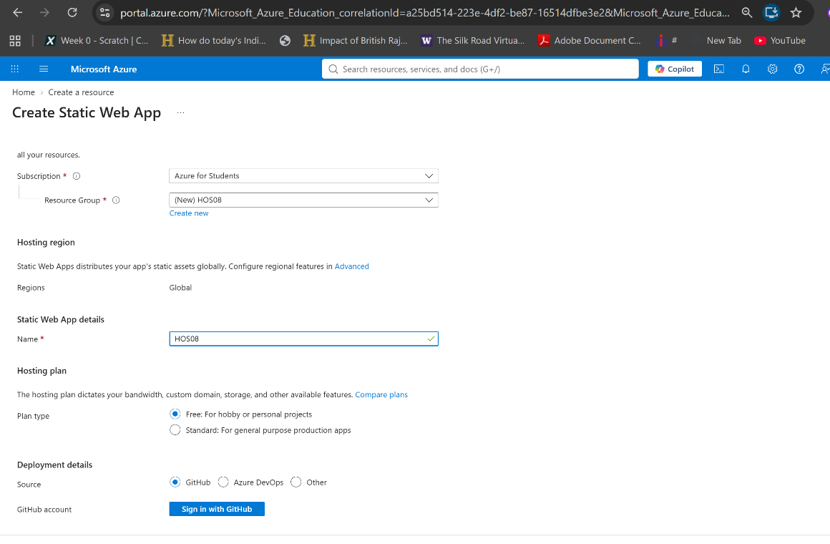

- Previewed the GitHub Actions workflow Azure would commit.
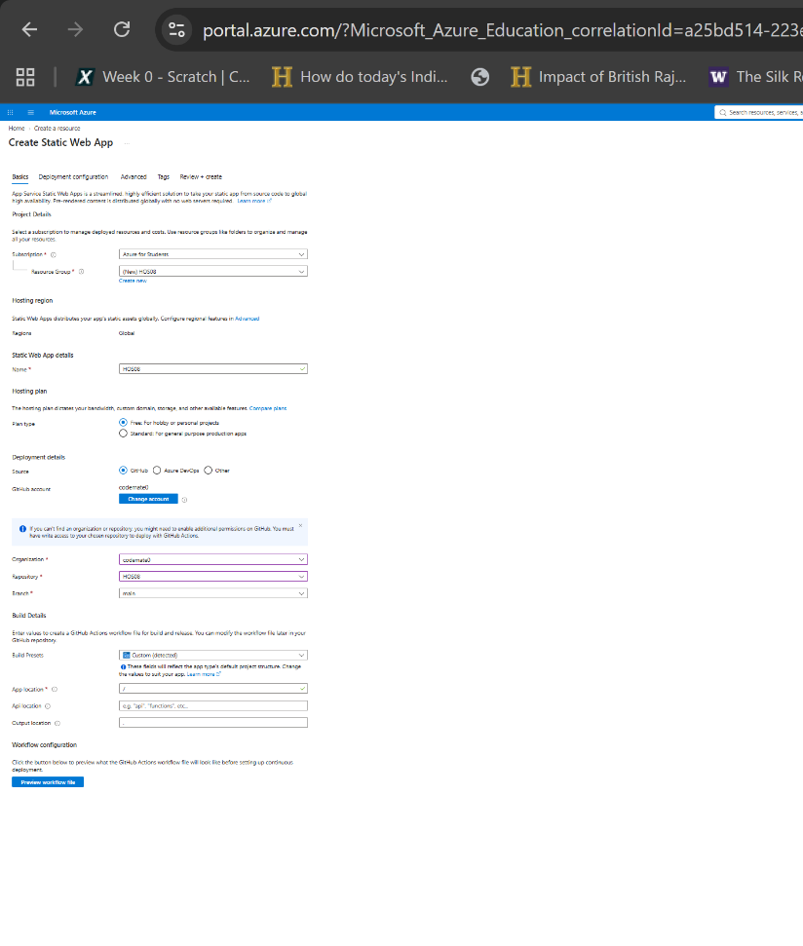
Note on Approach
Azure would not let me create a Static Web App, so I could not complete this HOS exactly as written.
My Azure for Students subscription carries a Microsoft-managed policy called "Allowed resource deployment regions." It restricts me to Norway East, Mexico Central, North Central US, West US 3, and Canada Central. Static Web Apps only runs in Central US, East US 2, West US 2, West Europe, and East Asia. No overlap, so every attempt failed with a RequestDisallowedByAzure error. Students cannot change this policy. It seems to apply to newly created subscriptions - mine was created the same day.
I deployed to Azure App Service instead, using the same GitHub Actions pipeline. Both learning outcomes still hold - a static website on Azure, and a CI/CD pipeline. Same repository, same index.html, same branch, pull request, merge, and automatic redeploy.
One extra fix was needed. Azure generates the workflow to match the runtime stack you pick, not what is in the repository, so it ran dotnet build and failed on my plain HTML. I removed the build steps and deployed the repository root directly. That is step 11.

C. Deploying to Azure App Service
- Connected Deployment Center to GitHub - organization codemate0, repository HOS08, branch main.
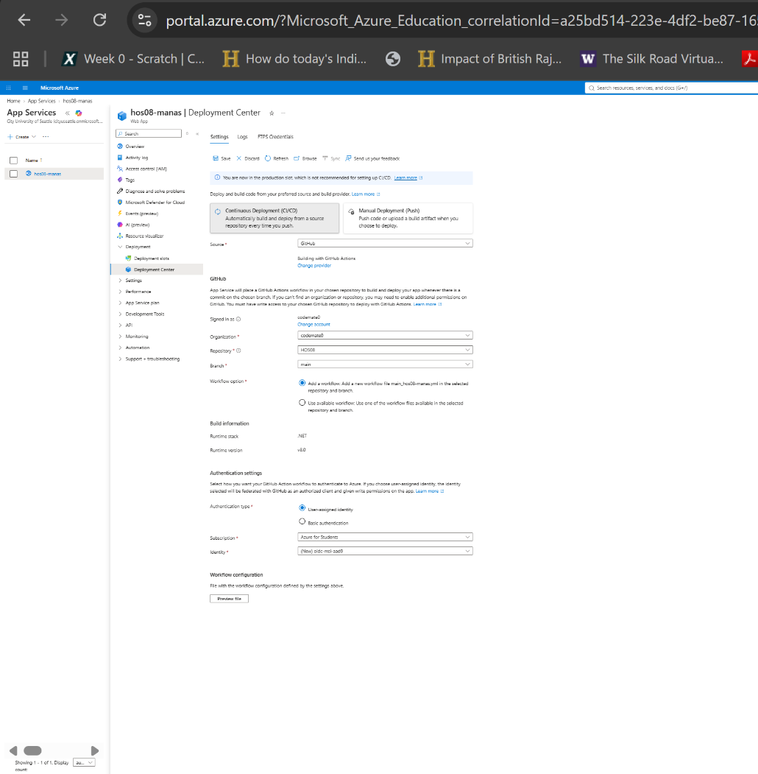
- The GitHub Actions workflow Azure generated.
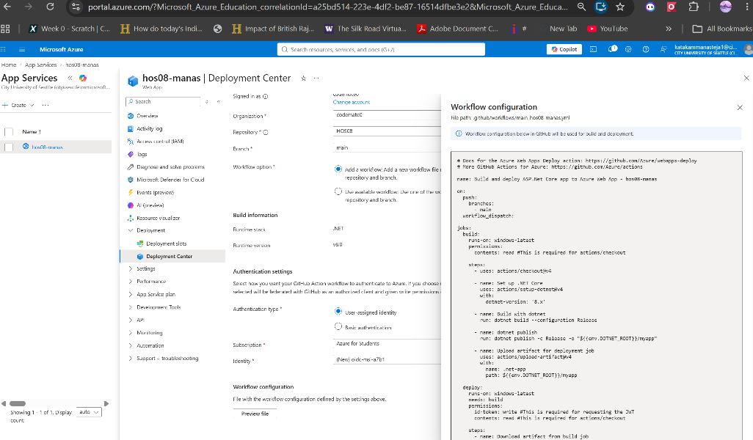
- Deployment Center saved with GitHub Actions as the build provider.
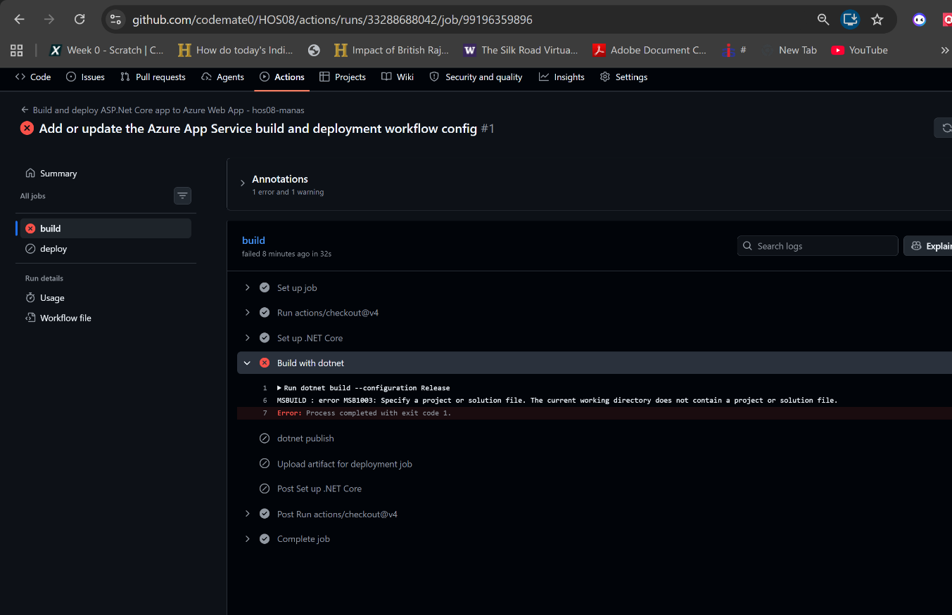
- First pipeline run failed. The generated workflow ran dotnet build, but the repository is plain HTML with no project file.
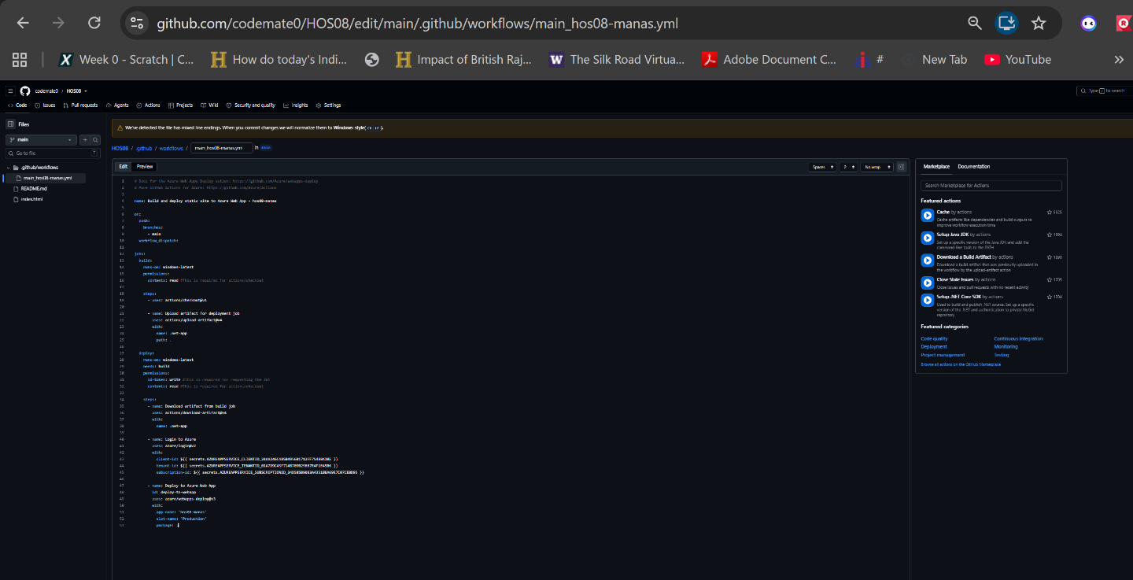

- Fixed the workflow by removing the dotnet build steps and deploying the repository root directly.
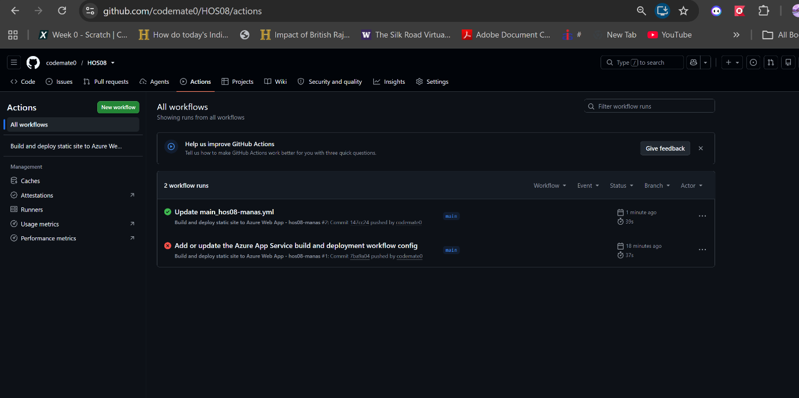
- Pipeline run succeeded.
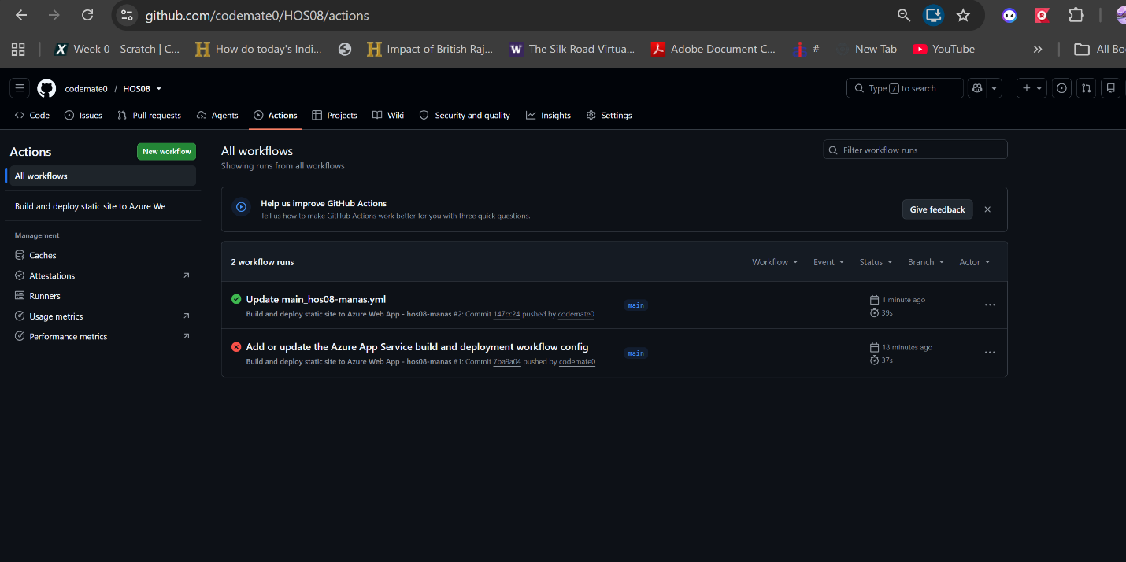

- The live site serving Hello.
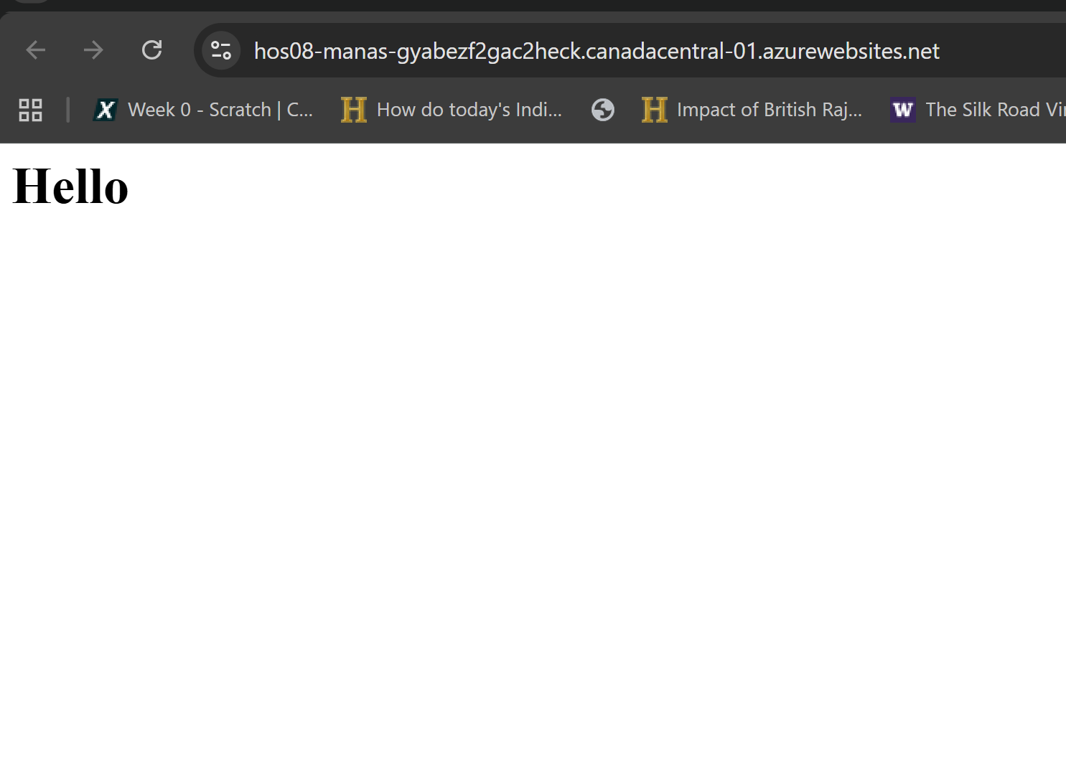
D. CI/CD Pipeline
- Created the development branch.
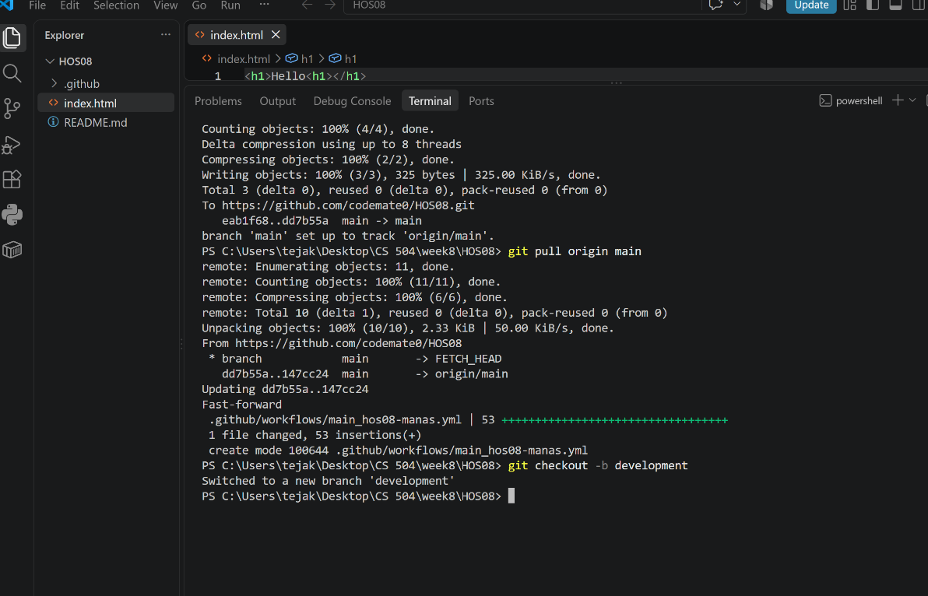
- Changed index.html to Hello World! on that branch.
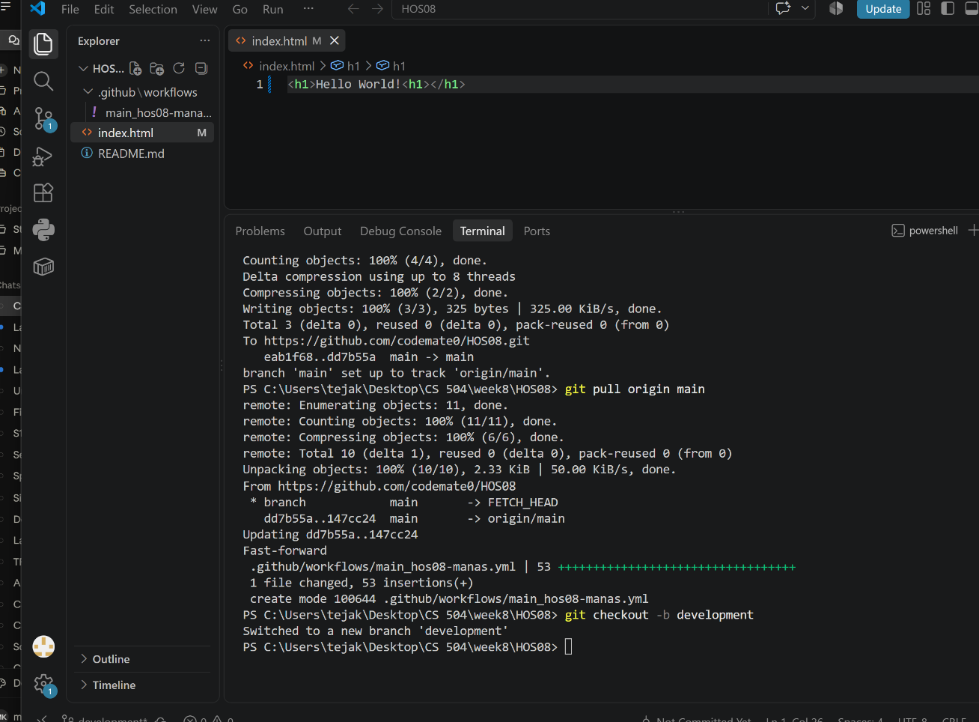
- Committed and pushed the development branch.
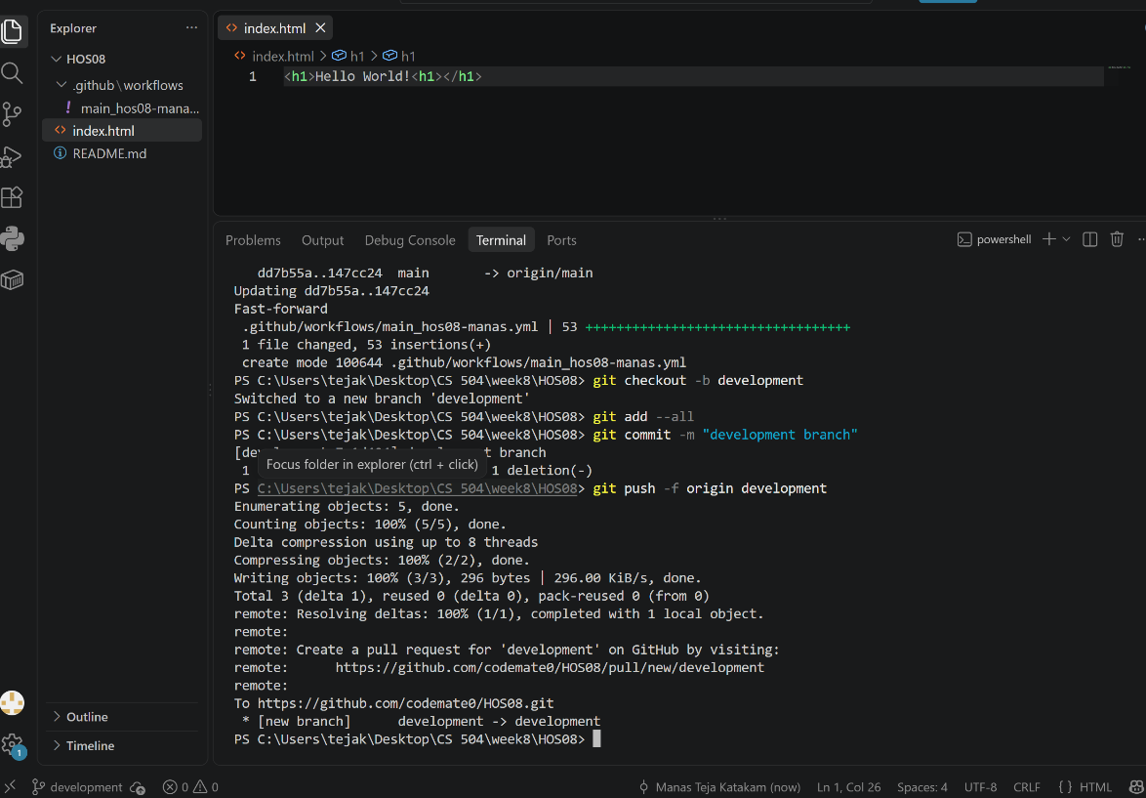
- GitHub offered Compare and pull request.
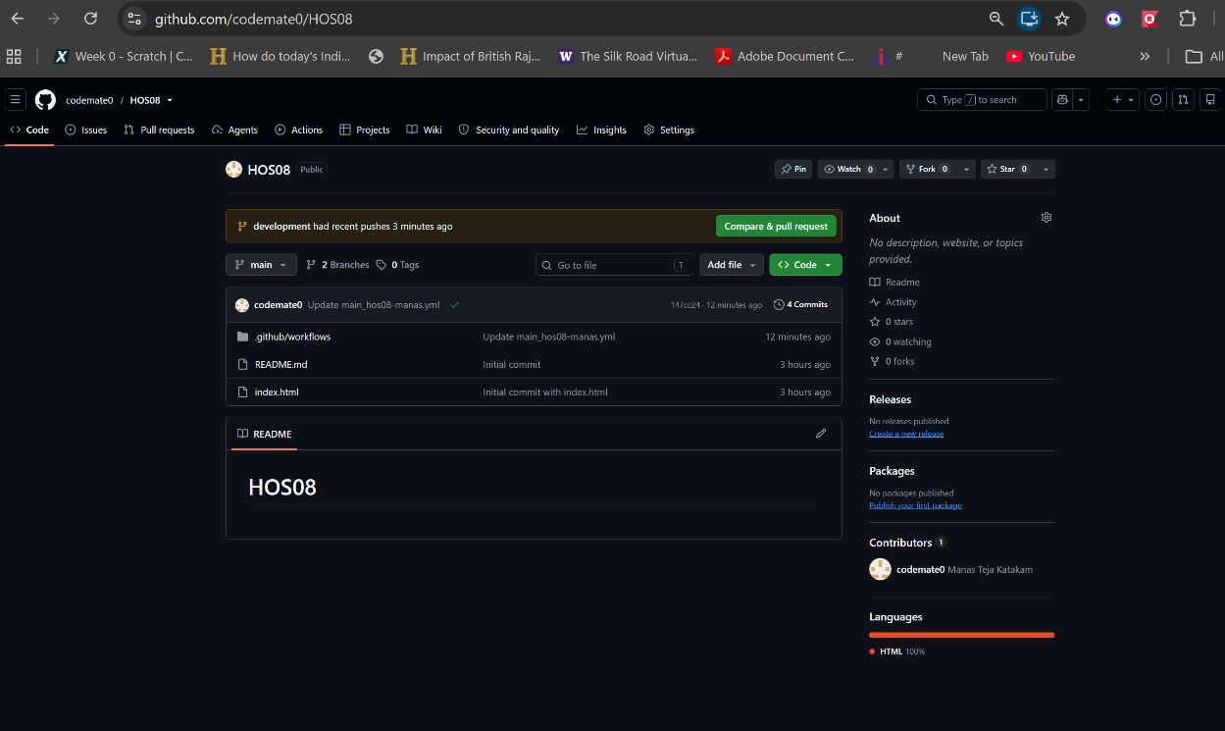
- Opened the pull request - base main, compare development.
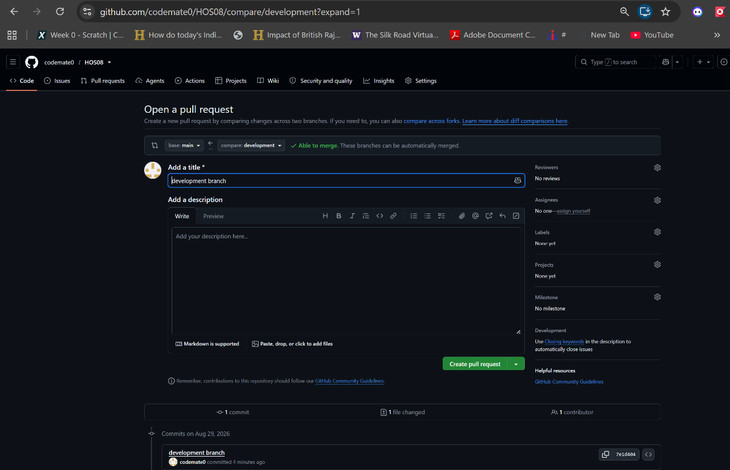

- Pull request ready to merge with no conflicts.
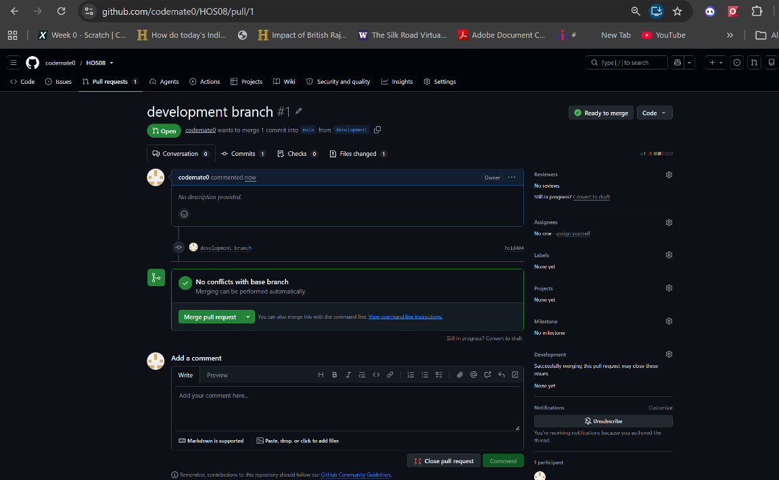
- Merged into main.
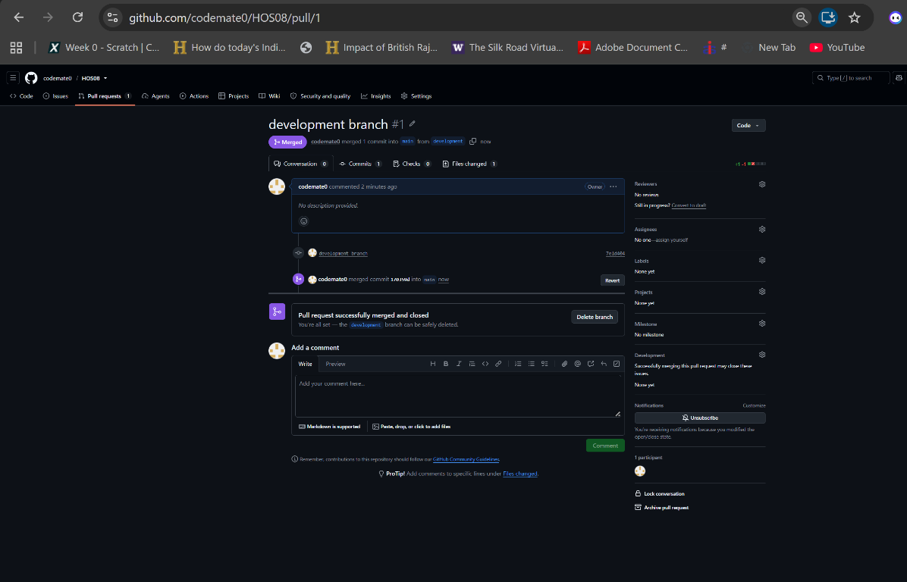

- The merge triggered the pipeline automatically and it completed.
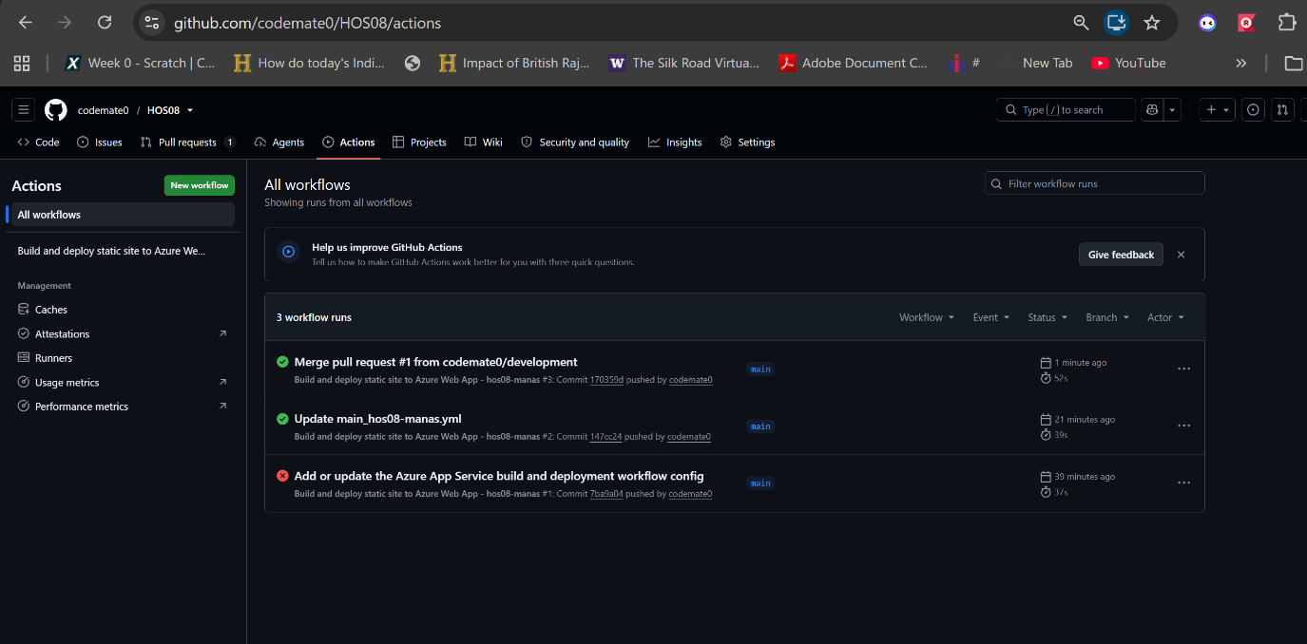
- The same URL now serves Hello World!, with no manual deployment.
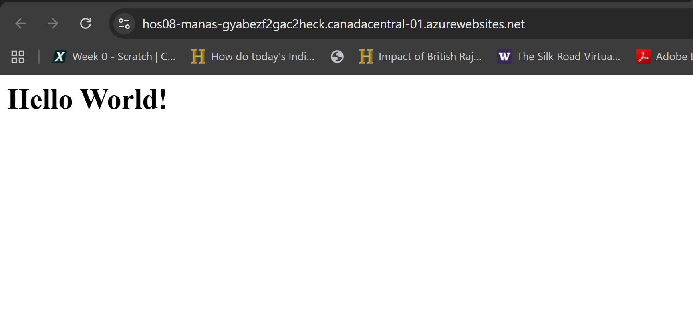

E. Cleanup
23. The HOS08 resource group before deletion.
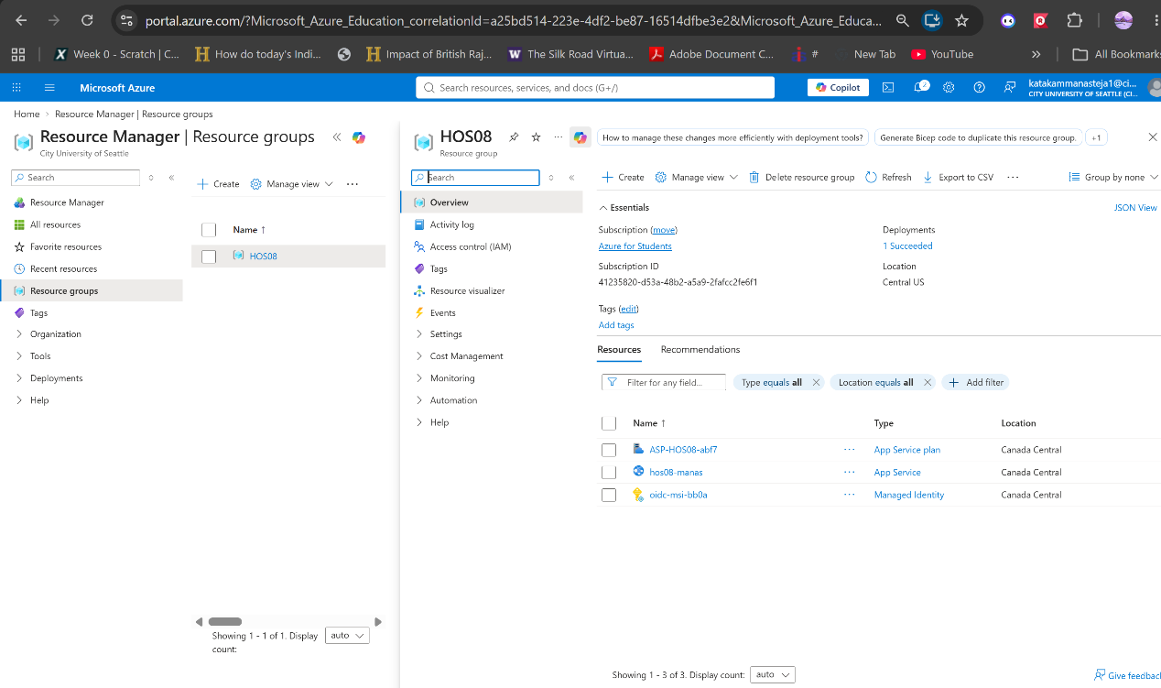
- Confirmed deletion of the resource group and all dependent resources.
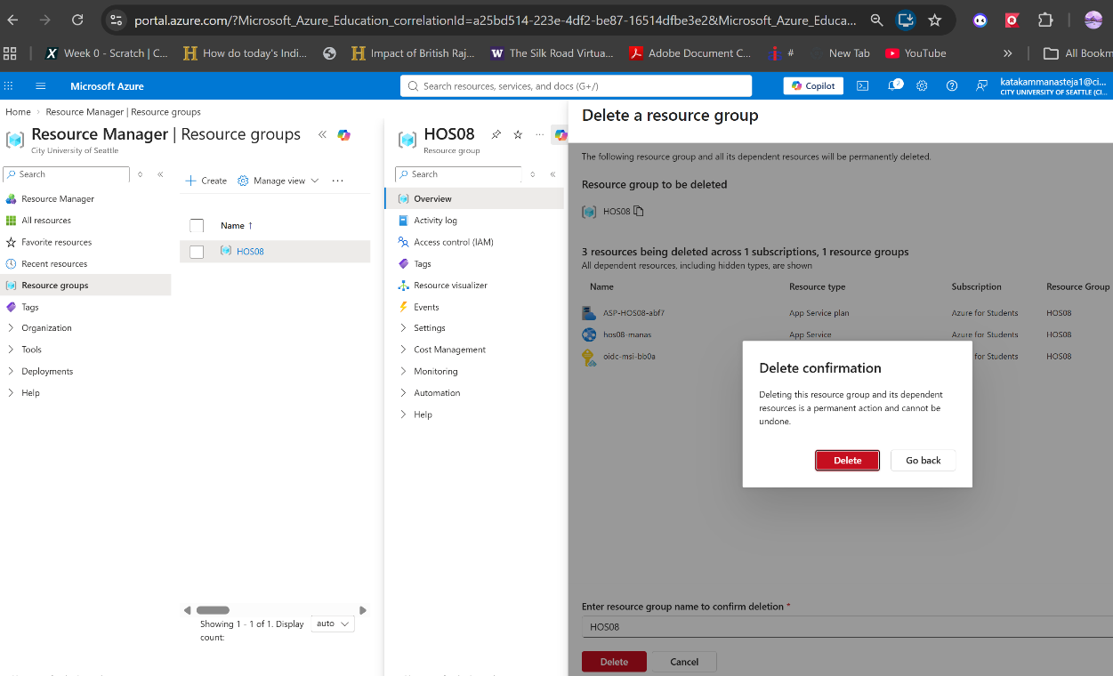

- Resource group deleted, nothing left consuming credit.
